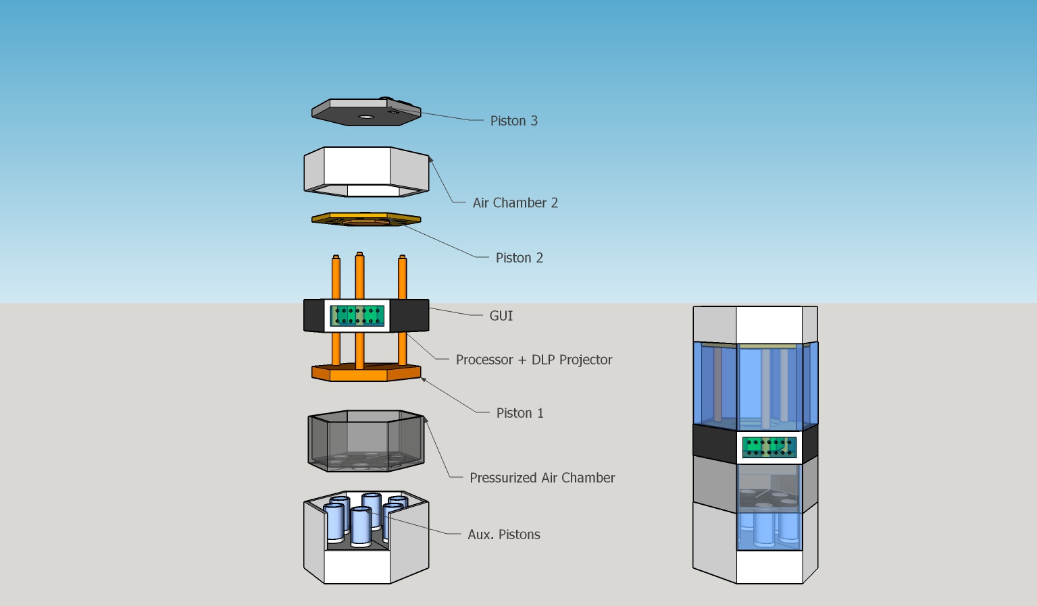

* Auxiliary pistons provide precision to the movement of piston 1
* Calculated and pressurized N2 inside the air chamber
* Raspberry Pi placed w. DLP projector
* nanoDLP as the software
* Screen works as a GUI and is connected to the processor
* Holes in the processor section in order to maintain hydrostatic equilibrium between piston 1 and processor section
* Mechanical locks between piston1 and piston2
* Object is formed between the surface of processor section (which is directly above DLP projector) and piston2
* Mechanical locks between piston2 and piston3
* They can be removed from the machine at the same time in order to remove the object

1. Airlocks on piston3 is opened
2. Piston3 removed
3. Piston2 attached to the surface of processor section
4. Filling in resins until the entire chamber is full
5. Airlocks on piston3 is closed
6. Piston2 (synchronized w. piston1) started to move up
7. Piston3 started moving down slowly due to the reduction of volume
8. Piston2 attached to piston 3
9. Airlocks on piston3 is opened
10. Remove piston3 &2 in order to get the object

